**BVPIEEE-IAS INDUCTION CEREMONY**

Industry Applications Society, IAS student chapter under the aegis of BVPIEEE (Student branch of IEEE in BVCOE) was recently given approval to be formed in Bharati Vidyapeeth College of Engineering, New Delhi. Induction ceremony for the same was held on 2nd March, 2015. Dr. Peter Magyar, Chairperson- Chapter and Membership Department, IAS-IEEE graced the occasion with his esteemed presence.

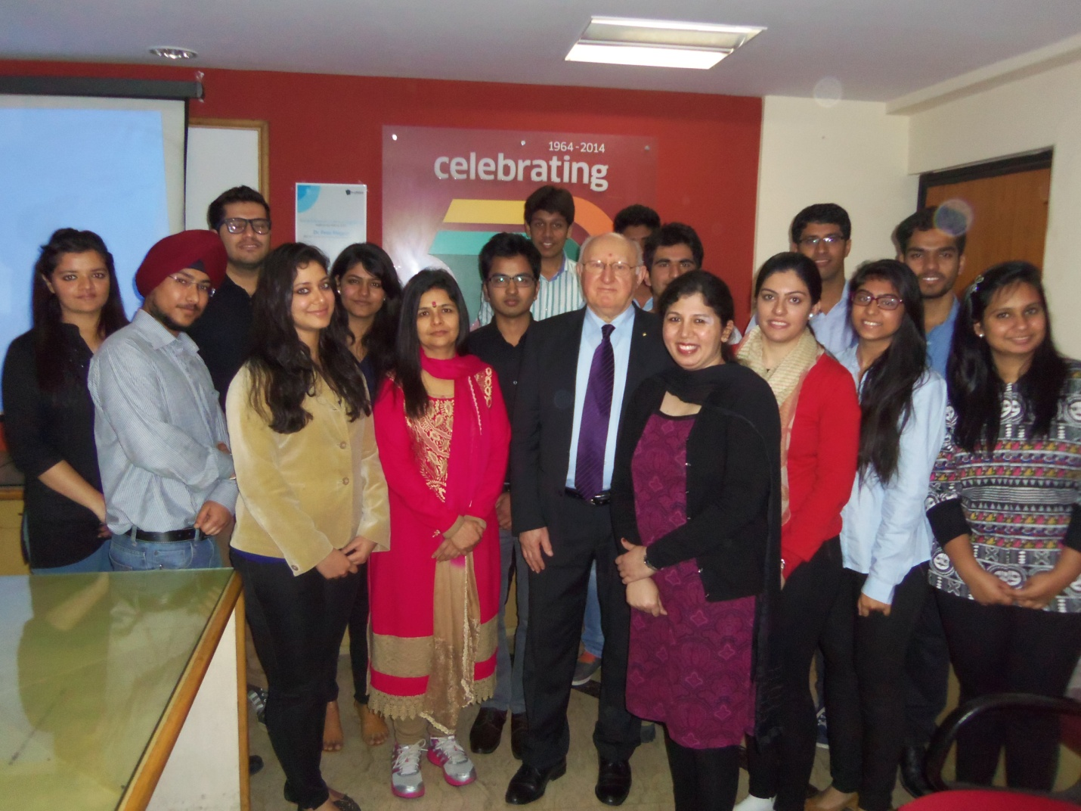

Along with Dr. Peter, Dr. Dharmendra Saini (Principal, BVCOE), Mrs. Yogita Arora(Branch counselor, BVPIEEE) and other respected faculty members were the guests for the event. The members of the executive committee of BVPIEEE and IAS were present for the same.   
The function began with the felicitation of Dr. Peter by the Principal. After exchanging greetings, lamp lighting ceremony took place for the auspicious occasion.   
Everybody attending the event was filled with enthusiasm and zest, especially Dr. Peter , who himself gave goods such as pens, badges etc to everyone and was busy interacting with the attendees.

A presentation about the college and BVPIEEE was given by the members of BVPIEEE. The presentation encompassed activities and milestones of BVPIEEE over the years. Principal sir imparted further information about the college. Following it, Dr. Peter explained in detail about IAS, various programs under its aegis & how it solves various problems faced by people around the world. He discussed about the benefits of being an IAS member and scholarships and grants that are given to aspiring students as well as faculty members. Later he had an interactive doubt session with the students and faculty where he took up doubts and explained in detail the functioning of IEEE-IAS and some of its chapters in India. Following it, Ms. Yamini Jain, Chairperson, BVPIEEE & Ms. Prerna Soni, Chairperson BVPIEEE-IAS and other members of BVPIEEE-IAS discussed about the future plans of the IAS student chapter of BVCOE.  
  
The induction ceremony comprised of oath taking ceremony by the new inductees, which took place after the address of the afore mentioned members. It was overseen by Mrs. Yogita and Dr. Peter. Following it, Dr. Peter was shown a tour of the entire college. The lunch took place after the tour, with the guests discussing more ideas and plans.

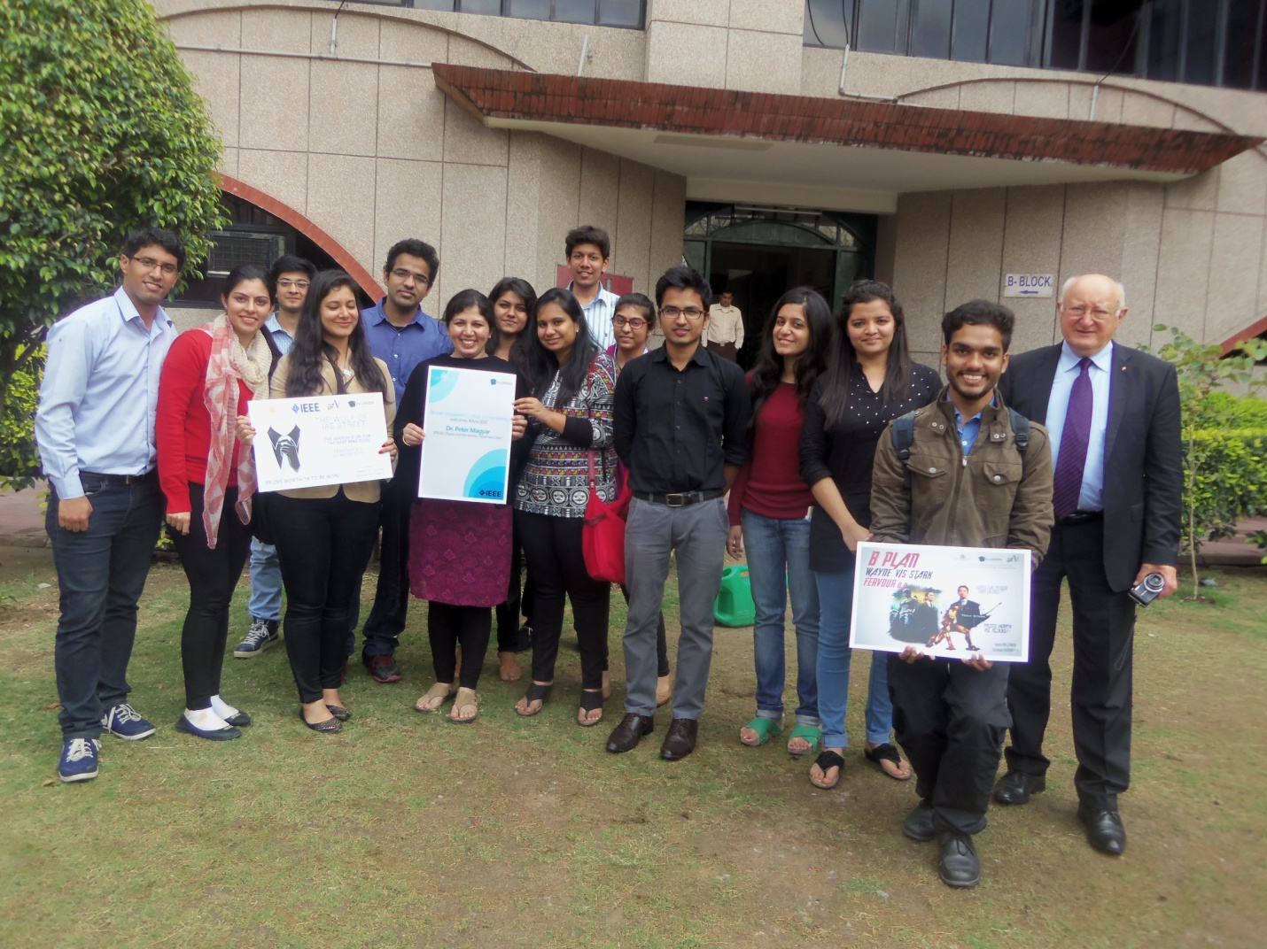

Since all good things come to an end, the induction ceremony ended with saplings plantation. Dr. Peter, faculty and student members planted saplings in the college greens symbolizing the establishment of the BVPIEEE-IAS chapter which will bloom into fruit bearing trees.

